PTR Operator Tasks

Code:
INCLUDE Irvine32.inc

.data
myWord WORD 1234h

.code
main PROC

mov ax, myWord

mov BYTE PTR myWord, 0ABh

call DumpRegs

exit
main ENDP
END main

Result:
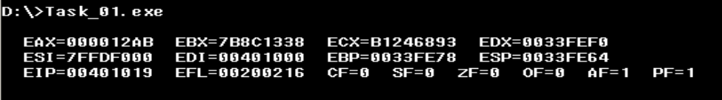

Code:
INCLUDE Irvine32.inc

.data
myDword DWORD 12345678h

.code
main PROC

mov al, BYTE PTR myDword
mov bl, BYTE PTR myDword+1
mov cl, BYTE PTR myDword+2
mov dl, BYTE PTR myDword+3

call DumpRegs

exit
main ENDP
END main

Result:
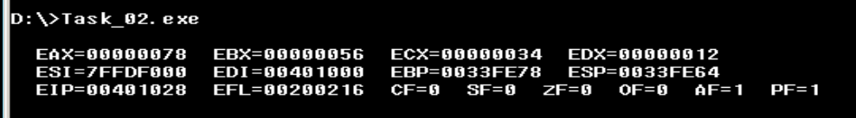

Code:
INCLUDE Irvine32.inc

.data
arr BYTE 11h,22h,33h,44h

.code
main PROC

mov ax, WORD PTR arr
mov bx, WORD PTR arr+1

call DumpRegs

exit
main ENDP
END main

Result:
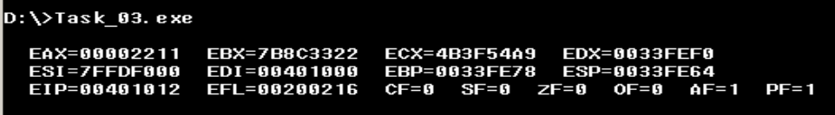

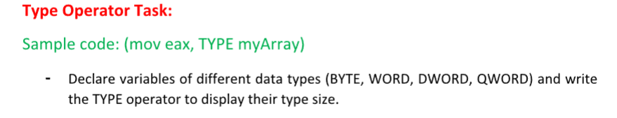
Code:
INCLUDE Irvine32.inc

.data
bVal BYTE 10h
wVal WORD 1234h
dVal DWORD 12345678h
qVal QWORD 1122334455667788h

.code
main PROC

mov eax, TYPE bVal
call WriteInt
call Crlf

mov eax, TYPE wVal
call WriteInt
call Crlf

mov eax, TYPE dVal
call WriteInt
call Crlf

mov eax, TYPE qVal
call WriteInt
call Crlf

exit
main ENDP
END main

Result:
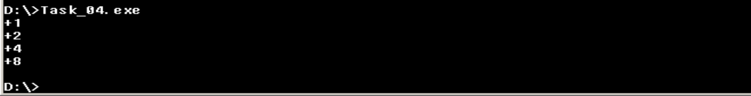

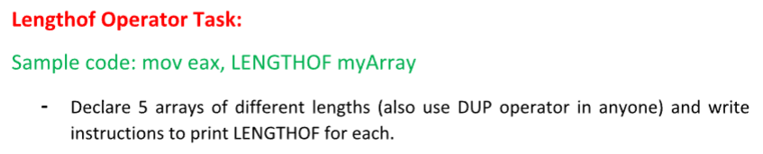
Code:
INCLUDE Irvine32.inc

.data
arr1 BYTE 1,2,3,4,5
arr2 WORD 10,20,30
arr3 DWORD 1,2
arr4 BYTE 10 DUP(0)
arr5 WORD 5 DUP(1)

.code
main PROC

mov eax, LENGTHOF arr1
call WriteInt
call Crlf

mov eax, LENGTHOF arr2
call WriteInt
call Crlf

mov eax, LENGTHOF arr3
call WriteInt
call Crlf

mov eax, LENGTHOF arr4
call WriteInt
call Crlf

mov eax, LENGTHOF arr5
call WriteInt
call Crlf

exit
main ENDP
END main

Result:
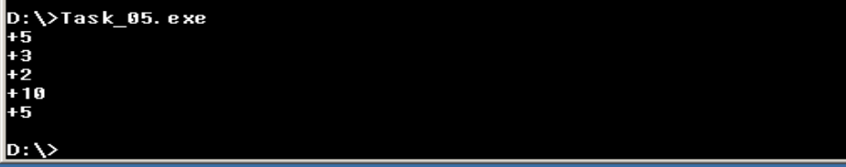

LENGTH OF x Type OF
Code:
INCLUDE Irvine32.inc

.data
arr BYTE 1,2,3,4,5

.code
main PROC

mov eax, LENGTHOF arr
mov ebx, TYPE arr
mul ebx

call WriteInt
call Crlf

exit
main ENDP
END main

Result:
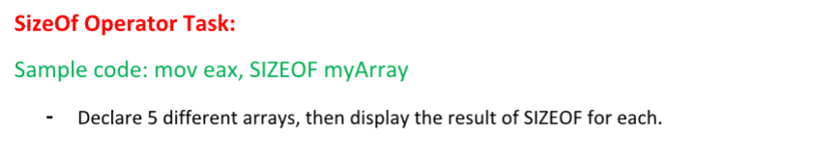
Code:
INCLUDE Irvine32.inc

.data
s1 BYTE 1,2,3
s2 WORD 1,2,3,4
s3 DWORD 1,2
s4 BYTE 6 DUP(0)
s5 WORD 2 DUP(5)

.code
main PROC

mov eax, SIZEOF s1
call WriteInt
call Crlf

mov eax, SIZEOF s2
call WriteInt
call Crlf

mov eax, SIZEOF s3
call WriteInt
call Crlf

mov eax, SIZEOF s4
call WriteInt
call Crlf

mov eax, SIZEOF s5
call WriteInt
call Crlf

exit
main ENDP
END main

Result:
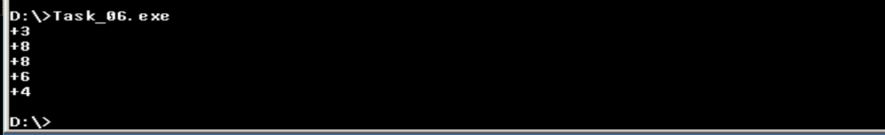

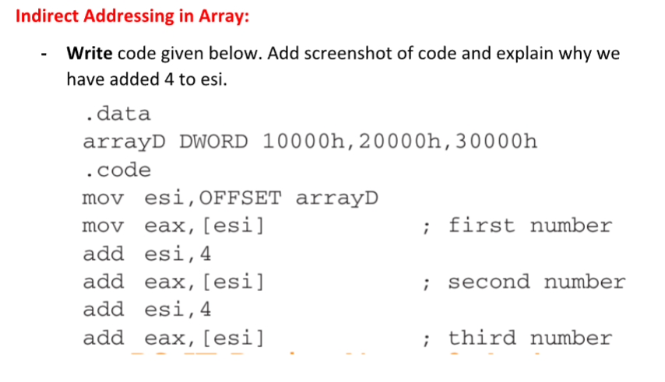
Explanation:

We add 4 to ESI because arrayD is a DWORD array and each DWORD = 4 bytes.
Address → +0 +4 +8
Value → 10000h 20000h 30000h

Code:
INCLUDE Irvine32.inc

.data
arrayD DWORD 10000h,20000h,30000h

.code
main PROC

mov esi, OFFSET arrayD

mov eax, [esi]

add esi, 4
add eax, [esi]

add esi, 4
add eax, [esi]

call DumpRegs

exit
main ENDP
END main

Result:
